1) Create an ArrayList and perform following operations for that:

a) Add

b) Update

c) Delete

d) Convert in to array

e) Display using iterator()

Code :

import java.util.*;

public class L9_1{

public static void main(String[] args)

{

ArrayList<String> list=new ArrayList<String>();

list.add("Rahul");

list.add("Karan");

list.add("Mihir");

list.add("Kaushal");

list.set(1, "Harry");

list.remove(2);

String[] arry = new String[list.size()];

arry = list.toArray(arry);

Iterator itr=list.iterator();

while(itr.hasNext()){

System.out.println(itr.next());

}

}

}

Output :

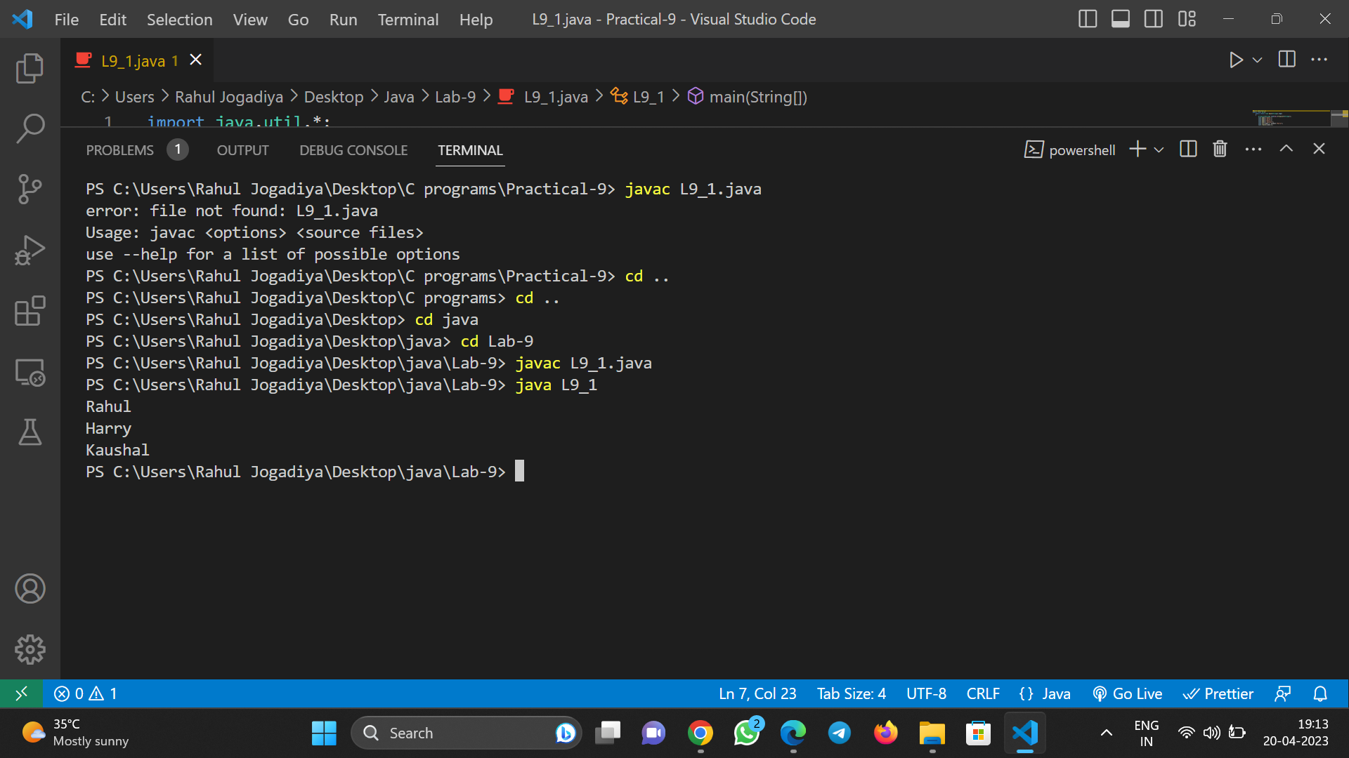

2) Create a LinkedList and perform following operations for that: a) Insert at first

b) Insert at last

c) Delete from first

d) Delete from last

e) Update specific index node value

f) Remove from specific index

g) Display using iterator()

Code :

import java.util.*;

public class L9_2{

public static void main(String[] args)

{

LinkedList<String> list=new LinkedList<String>();

list.addFirst("Rahul");

list.addLast("Mihir");

list.addFirst("Karan");

list.addFirst("Vivek");

list.addLast("Jaivin");

list.removeFirst();

list.removeLast();

list.set(0,"Rushit");

list.remove(0);

Iterator itr=list.iterator();

while(itr.hasNext()){

System.out.println(itr.next());

}

}

}

Output:

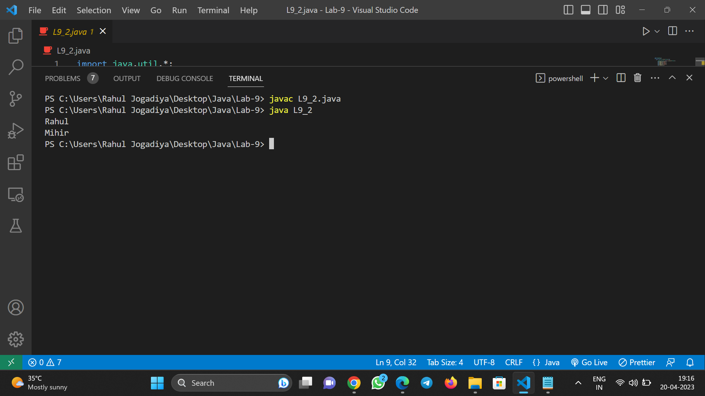

3) Create a HashSet and perform following operations for that: a) Insert

b) Update

c) Delete

d) Display using iterator()

Code:

import java.util.*;

public class L9_3{

public static void main(String[] args)

{

HashSet<String> set=new HashSet();

set.add("Rahul");

set.add("Roshan");

set.add("Kaushal");

set.remove("Rahul");

Iterator itr=set.iterator();

while(itr.hasNext()){

System.out.println(itr.next());

}

}

}

Output:

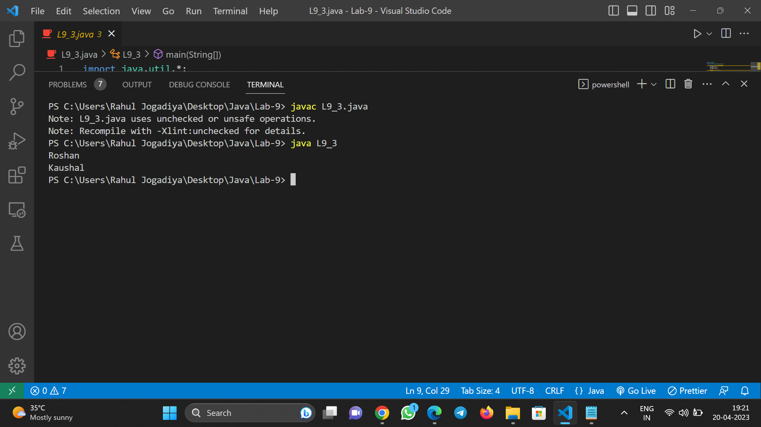

4) Create a HashMap and perform following operations for that: a) Insert

b) Update

c) Delete

d) Display using iterator()

Code:

import java.util.*;

public class L9_4{

public static void main(String[] args)

{

HashMap<Integer,String> map=new HashMap();

map.put(1,"Mihir Bachhani");

map.put(2,"Karan Garle");

map.put(3,"Rahul Jogadiya");

map.replace(1, "Gaurav Khanna");

map.remove(2);

Iterator <Integer> it = map.keySet().iterator();//keyset is a method

while(it.hasNext())

{

int key=(int)it.next();

System.out.println(key + " " + map.get(key));

}

}

}

Output :

